Hey J,

I agree with the first paragraph, but take a look at the second and third paragraphs you highlighted in yellow. It is a bit redundant to information in the bullet points and the education subject is introduced for a second time. What do you think about just going with the first paragraph you suggested skipping the second and third?

Hi << Test First Name >>,
As a respected senior executive in the food and beverage industry…


<< Test First Name >> << Test Last Name >>
You are cordially invited to join
an elite group of 80 prestigious independent
food and beverage executives to be hosted* at
BITAC Food & Beverage 2019
January 20 - 22, 2019
Grand Hyatt Baha Mar
Nassau, Bahamas
* Hosted executives will have their
~ registration fee waived
~ accommodations comp’d
~ roundtrip airfare reimbursed
~ and enjoy seven gourmet meals
with three receptions during the event
View Full Details: http://bitac.net/files/Invitation_FB_b.pdf


BITAC Food & Beverage is an idea generating event designed specifically for senior executive team members to help grow and enhance their food and beverage business. This highly respected event is acclaimed for:
• | invitation-only format to control quantity, quality and promote maximum ROI
• | interaction with peers (top leaders and companies in industry)
• | interactive panel discussions with industry experts
• | stimulating ideas and forging new vendor relationships to improve the guest experience, improve efficiency and reducing costs

BITAC offers a wide array of new and innovative products and services to equip, furnish and run F&B, catering or convention services departments in a lodging property or restaurant. They will find such products as: food, beverages, uniforms, kitchen equipment, beverage equipment, FF&E, tabletop, banquet equipment, lighting, marketing, signage, technology, OS&E, room service, and much more.

6 months' worth of work in 2+ days! Gain insight from fellow restaurateurs, executive chefs, purchasing executives, and operations professionals. Improve operational efficiency, discover new and better products, Lower your costs.
BITAC provides an intimate atmosphere for prominent executives in the industry to exchange ideas.
The interactive educational sessions provide a setting to share experiences and gain insight from peers on the issues and challenges in today's market. It is the most productive, cost effective and time-saving method to build knowledge and contacts.

Please take a look at your calendar and let me know, by simple reply to this email, if you are free to attend at BITAC Food & Beverage January 20 - 22, 2019 at the Grand Hyatt Baha Mar in Nassau Bahamas.
I look forward to hearing from you. Please contact me if you have any questions.
Best,

 | J. Viola  Chief Operating Officer  BITAC, Inc.  Direct: (631) 424-7755 x106  Cell: 973-617-6473  jviola@bitac.net | 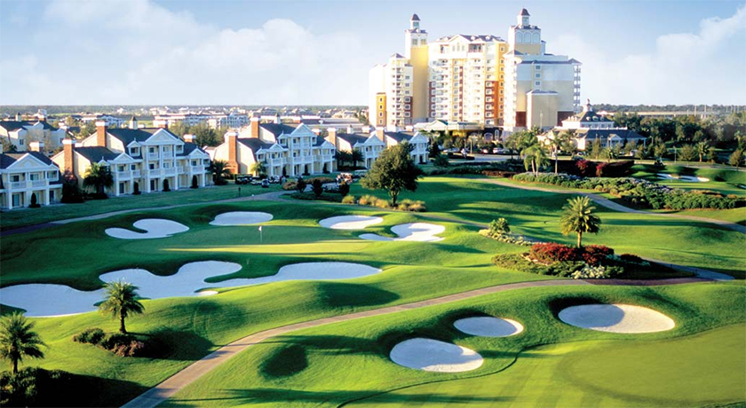 | BITAC® Independent 2018  January 20 - 22, 2019  Grand Hyatt Baha Mar  Nassau, Bahamas

This email was sent to jviola@hotelinteractive.com
why did I get this? unsubscribe from this list update subscription preferences
BITAC · 150 E Main St · Smithtown, NY 11787-2869 · USA

